SIMATS ENGINEERING
ASSESSMENT TOOL 2

COURSE NAME: Artificial Intelligence COURSE CODE: CSA17

COURSE OUTCOME COVERED

CO2: Experiment search and game-solving techniques such as Greedy Search, A*, CSP, Minimax, and Alpha-Beta pruning with heuristic functions for solving complex AI problems efficiently. (BL3)

Assessment Tool Weightage: 50%

Duration: 1 Hour
QUESTIONS: 3 Total Marks:50

Annexure A

Scenario Based Assignment

Code of Conduct:

I Dharshan B (Name / Reg No) certify that this submission is my original work and that I have adhered to the guidelines specified for this assessment.
I understand that any violation of academic integrity rules will result in disciplinary action.

Signature of the student:
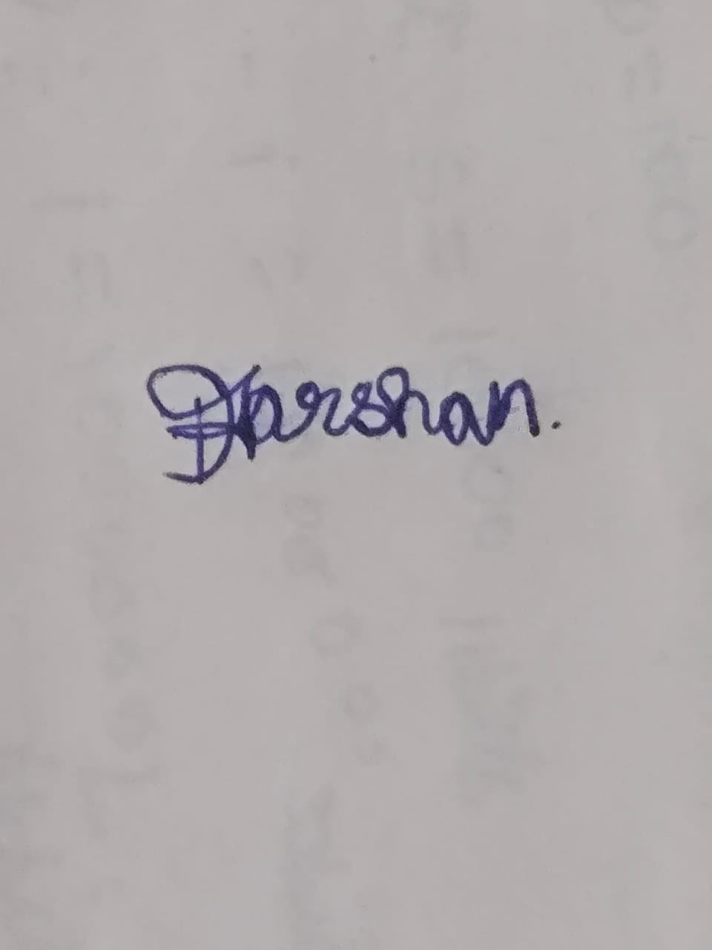

1. Firefighting Robot – Online Search Agent

i. Why does this problem require an online search agent?
- The robot does not have a complete map of the building before starting.
- It discovers corridors, rooms, obstacles, fire zones, and trapped occupants while moving.
- Therefore, the robot must search and act simultaneously, updating its plan based on new information.
- Offline search is unsuitable because it assumes the environment and state space are known in advance.

ii. Challenges of partial observability and dynamic environments
- Partial observability: Smoke, darkness, and damaged structures prevent the robot from seeing the complete surroundings.
- Sensor readings may be incomplete, noisy, or inaccurate.
- Dynamic environment: Fire can spread, structures can collapse, and paths can become blocked.
- The robot must continuously reconsider its route when conditions change.
- Safety is critical because a previously safe path may become dangerous within seconds.

iii. How does the robot build and update its internal model?
The robot uses sensors such as cameras, LiDAR, thermal sensors, and gas sensors to collect information.
Process:
Sensors → Perception → Local Map → Update Environment Model → Search → Action
- Initially, the robot has only limited knowledge about its surroundings.
- As it moves, it records obstacles, free paths, fire locations, and possible victims.
- It creates an occupancy/grid map or similar internal representation.
- New sensor information updates the map continuously.
- The robot then selects the safest and most useful next action based on the updated model.

iv. Online search vs uninformed and informed search
Strategy | Knowledge | Suitability
Uninformed Search | No domain-specific knowledge | Poor for unknown, dangerous environments
Informed Search | Uses heuristic information | Better, but depends on reliable knowledge
Online Search | Learns environment while acting | Most suitable for unknown environments
- BFS/DFS may explore unnecessarily many locations.
- A* can find good paths when a useful map and heuristic are available.
- Online search is better because it can adapt its search as new information becomes available.

v. Most suitable approach
An online, heuristic-based search approach is most suitable.
- It handles uncertainty by continuously gathering sensor information.
- It provides adaptability because the route can be changed when fire or obstacles appear.
- Safety costs can be included in the search, giving dangerous areas a very high cost.
- A practical system can combine online exploration + A/D Lite-style replanning + sensor-based obstacle avoidance.
Conclusion: An online search agent is preferred because the robot must continuously observe, learn, plan, and act in an uncertain and changing environment.

2. Airport Gate Assignment – Constraint Satisfaction Problem

CSP Formulation
A Constraint Satisfaction Problem (CSP) consists of:
CSP = Variables + Domains + Constraints

i. Variables, domains, and constraints

Variables
Each arriving flight is treated as a variable.
Example:
F1, F2, F3, ..., Fn
Each variable represents the gate assigned to that flight.

Domains
The domain of each flight contains the gates that it can potentially use.
Example:
D(F1) = {G1, G2, G3}
A wide-body flight may have:
D(F2) = {G1, G3}
if only G1 and G3 can accommodate wide-body aircraft.

Constraints
1. No overlapping flights at the same gate
If two flights overlap in time:
Gate(F1) ≠ Gate(F2)
2. Aircraft compatibility
A wide-body aircraft must be assigned only to a wide-body-compatible gate.
3. Airline preferences
Preferred gates should be assigned to particular airlines whenever possible.
4. Ground crew availability
A gate assignment must not require unavailable ground crew during the required time.
5. Connecting-flight requirements
Delayed connecting flights may receive gates that minimize transfer time.
Thus, the solution must satisfy all hard constraints while optimizing soft preferences.

ii. How backtracking search works
Backtracking assigns gates to flights one at a time.
Process:
- Select an unassigned flight.
- Select a possible gate from its domain.
- Check whether the assignment violates any constraint.
- If valid, continue with the next flight.
- If invalid, try another gate.
- If no gate is possible, return to the previous assignment and change it.

Example:
F1 → G1 ✓
F2 → G1 ✗ overlapping
F2 → G2 ✓
F3 → G2 ✗ incompatible
F3 → G3 ✓
This process continues until a valid assignment is found.

iii. Constraint propagation / Forward checking
Forward checking improves backtracking by removing impossible values from future variables.
Example:
Suppose:
F1 → G1
and F2 overlaps with F1.
Forward checking immediately removes G1 from F2's domain:
D(F2) = {G1, G2, G3}
becomes:
D(F2) = {G2, G3}
Benefits:
- Detects conflicts earlier.
- Reduces unnecessary search.
- Prevents the algorithm from exploring impossible assignments.
- Makes large scheduling problems more manageable.
Useful CSP techniques include:
- Forward checking
- Arc consistency
- Minimum Remaining Values (MRV)
- Degree heuristic
- Least Constraining Value (LCV)

iv. Real-world challenges and best strategy for scalability
As the number of flights and gates increases, the search space grows rapidly.
Challenges include:
- Flight delays and cancellations.
- Gate maintenance or temporary closure.
- Changing aircraft types.
- Crew availability changes.
- Passenger connection requirements.
- Multiple competing airline preferences.
- Real-time changes in arrival/departure times.

Best strategy
A constraint-based backtracking system with propagation and heuristics is suitable.
A strong approach is:
CSP + Backtracking + Forward Checking + MRV + Arc Consistency
- MRV selects the flight with the fewest available gates first.
- Forward checking removes conflicting gates early.
- Arc consistency further reduces inconsistent domain values.
- Soft constraints can be handled using optimization/cost functions.
Conclusion: CSP is highly suitable because airport gate assignment naturally consists of variables, possible gate assignments, and multiple constraints.

3. Board-Game AI – Minimax and Alpha-Beta Pruning

i. How Minimax models the problem
The board game can be represented as a game tree.
- Each node represents a board state.
- Each edge represents a legal move.
- One level represents the AI's move.
- The next level represents the opponent's move.
The AI is the MAX player, trying to maximize its score.
The opponent is the MIN player, trying to minimize the AI's score.
Example:
Current State
↓
Possible AI Moves
↓
Possible Opponent Moves
↓
Future Board States
↓
Evaluation
Minimax assumes both players make rational decisions.

ii. Computational challenges of large game trees
If:
- Branching factor = b
- Search depth = d
then the number of nodes can be approximately:
O(bᵈ)
For example, if there are 8 possible moves at each level and depth is 6:
8⁶ = 262,144
possible leaf positions, before considering additional overhead.
Challenges include:
- Huge number of possible moves.
- Limited CPU and memory on tablets.
- Strict response-time requirements.
- Deeper searches require much more computation.
- Evaluating every possible state is impractical.
Therefore, the AI needs techniques that reduce unnecessary computation.

iii. Alpha-Beta pruning
Alpha-Beta pruning improves Minimax by eliminating branches that cannot affect the final decision.
It maintains two values:
- Alpha (α): Best value MAX can guarantee so far.
- Beta (β): Best value MIN can guarantee so far.

Detailed reasoning
Suppose MAX has already found a move giving:
α = 5
Now, while examining another branch, MIN finds a move producing:
β = 3
Since MIN can already force a value of 3, MAX would never choose this branch over the previously known value 5.
Therefore:
β ≤ α
and the remaining branches can be pruned.
This avoids evaluating unnecessary nodes.

Advantages
- Produces the same optimal move as Minimax when searching to the same depth.
- Reduces computation significantly.
- Allows deeper search within the same time limit.
- Particularly effective when good moves are examined first.
In the best case, the effective complexity can approach:
O(b^(d/2))
instead of:
O(bᵈ)

iv. Evaluation function design
Because the complete game tree cannot be searched, the AI stops at a fixed depth and evaluates the resulting board.
A possible evaluation function is:
Evaluation = 5(Material) + 3(Position) + 4(Mobility) + 6(Safety) + 2(Threats)
Factors can include:
- Material/number of pieces – More pieces generally provide an advantage.
- Position – Strong or strategically important board positions receive higher scores.
- Mobility – More available legal moves indicate greater flexibility.
- Safety – Protecting important pieces from capture is valuable.
- Threats – Potential captures or attacks increase the evaluation.
- Promotion/advanced pieces – Pieces closer to achieving important objectives receive additional value.
The weights should be tuned through testing to reflect the actual game strategy.

v. Strategy for balancing optimality and real-time performance
The best solution is:
Depth-limited Minimax + Alpha-Beta pruning + Good evaluation function + Move ordering
Recommended techniques:
- Use Alpha-Beta pruning to reduce the number of evaluated states.
- Use iterative deepening to search progressively deeper while respecting the time limit.
- Use move ordering so strong moves are examined first, increasing pruning.
- Use transposition tables to avoid evaluating repeated board states.
- Adjust search depth according to the available processing time.
- Use a lightweight evaluation function suitable for low-power tablets.

Overall architecture
Game State
↓
Generate Legal Moves
↓
Move Ordering
↓
Alpha-Beta Minimax
↓
Depth/Time Limit
↓
Evaluation Function
↓
Best Move
Conclusion: For a low-power tablet, iterative-deepening Minimax with Alpha-Beta pruning and an efficient evaluation function provides the best balance between playing strength, computation, and real-time response.

